**Deliverable 2:**

**• Project: Develop a Todo application using the MERN stack. Include setup instructions,**

**code snippets, and screenshots showing the application’s functionality.**

**Problem Statement-** To-Do List

Setup steps for React app-

1. Creating a react app

npx create-react-app .

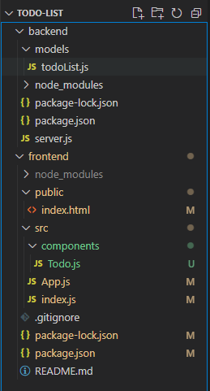

2.)npm init:

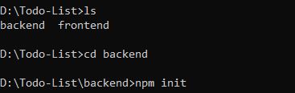

**2.) package.json**

**For frontend:**

"dependencies": {  
 "@testing-library/jest-dom": "^5.17.0",  
 "@testing-library/react": "^13.4.0",  
 "@testing-library/user-event": "^13.5.0",  
 "axios": "^1.5.0",  
 "bootstrap": "^5.3.2",  
 "react": "^18.2.0",  
 "react-dom": "^18.2.0",  
 "react-router-dom": "^6.16.0",  
 "react-scripts": "5.0.1",  
 "web-vitals": "^2.1.4"  
}

For backend:

"dependencies": {  
 "cors": "^2.8.5",  
 "express": "^4.18.2",  
 "mongoose": "^7.5.2"  
}

Writing code for frontend

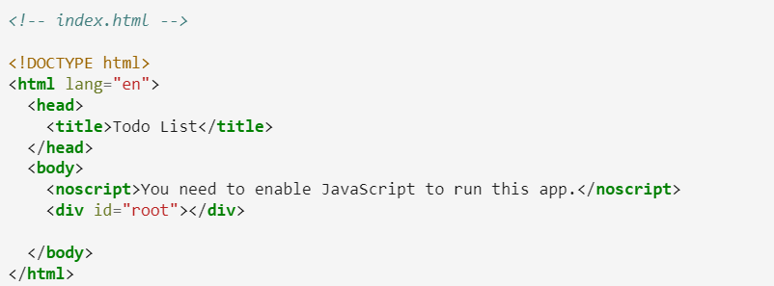

**Writing code for backend**

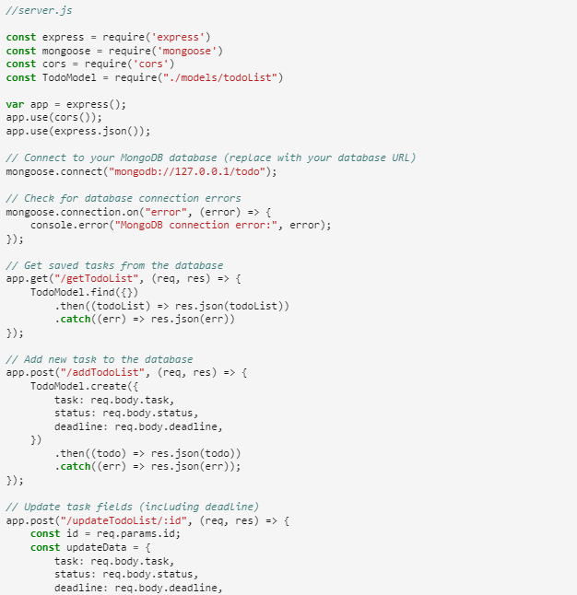

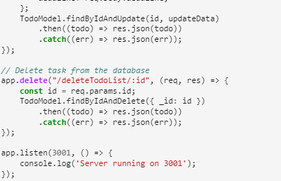

1. Saving code and Launching the app

npm start

http://localhost:3000/

Result-

